DP-203 - Data Engineering - Day 8
Wednesday, September 20, 2023
9:06 AM

Data Engineering on Microsoft Azure
https://learn.microsoft.com/en-us/training/courses/dp-203t00

Create a Synapse Analytics Serverless Pool

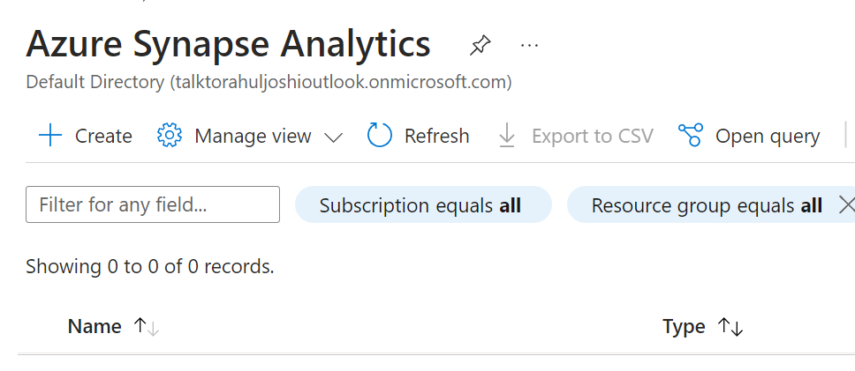

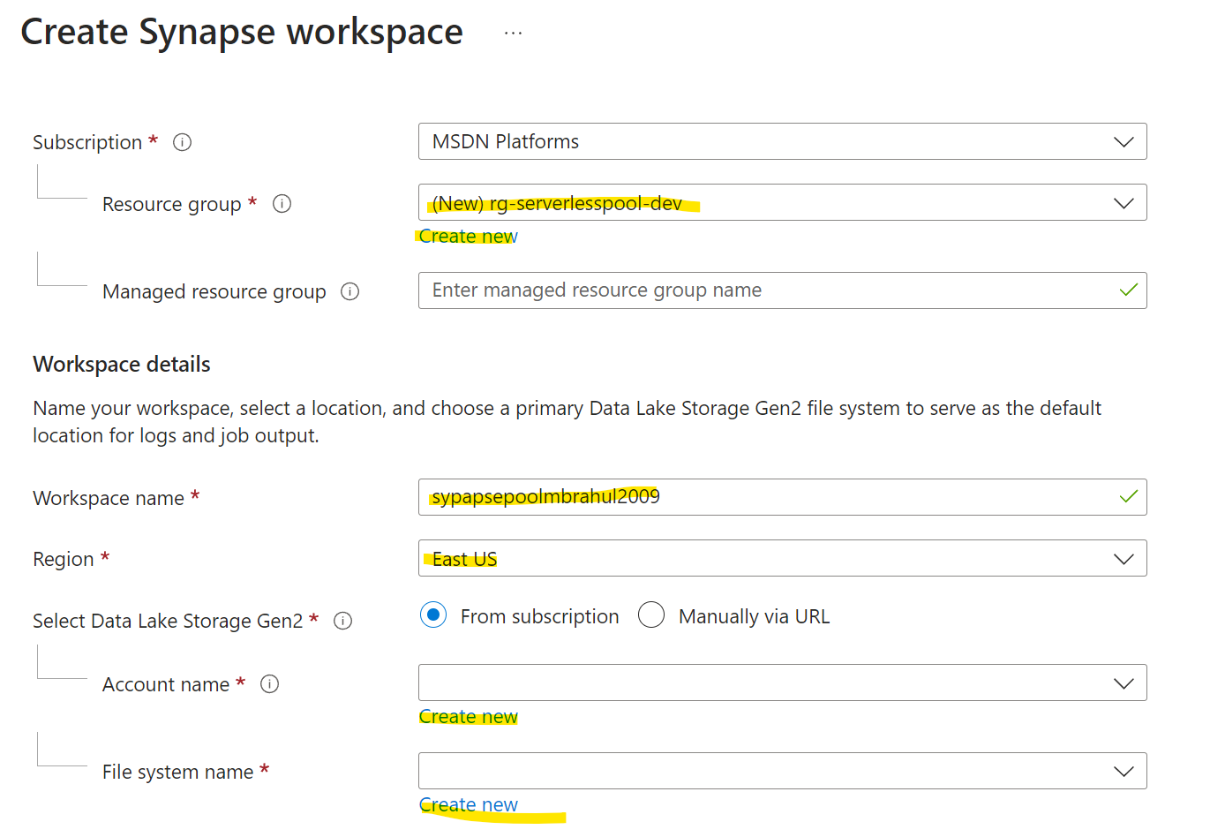

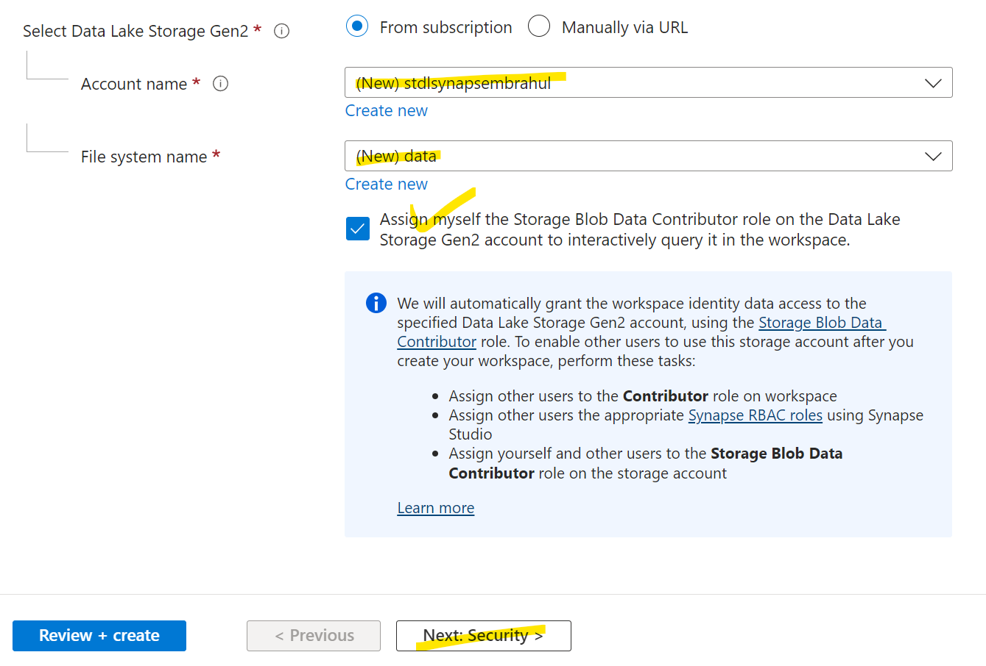

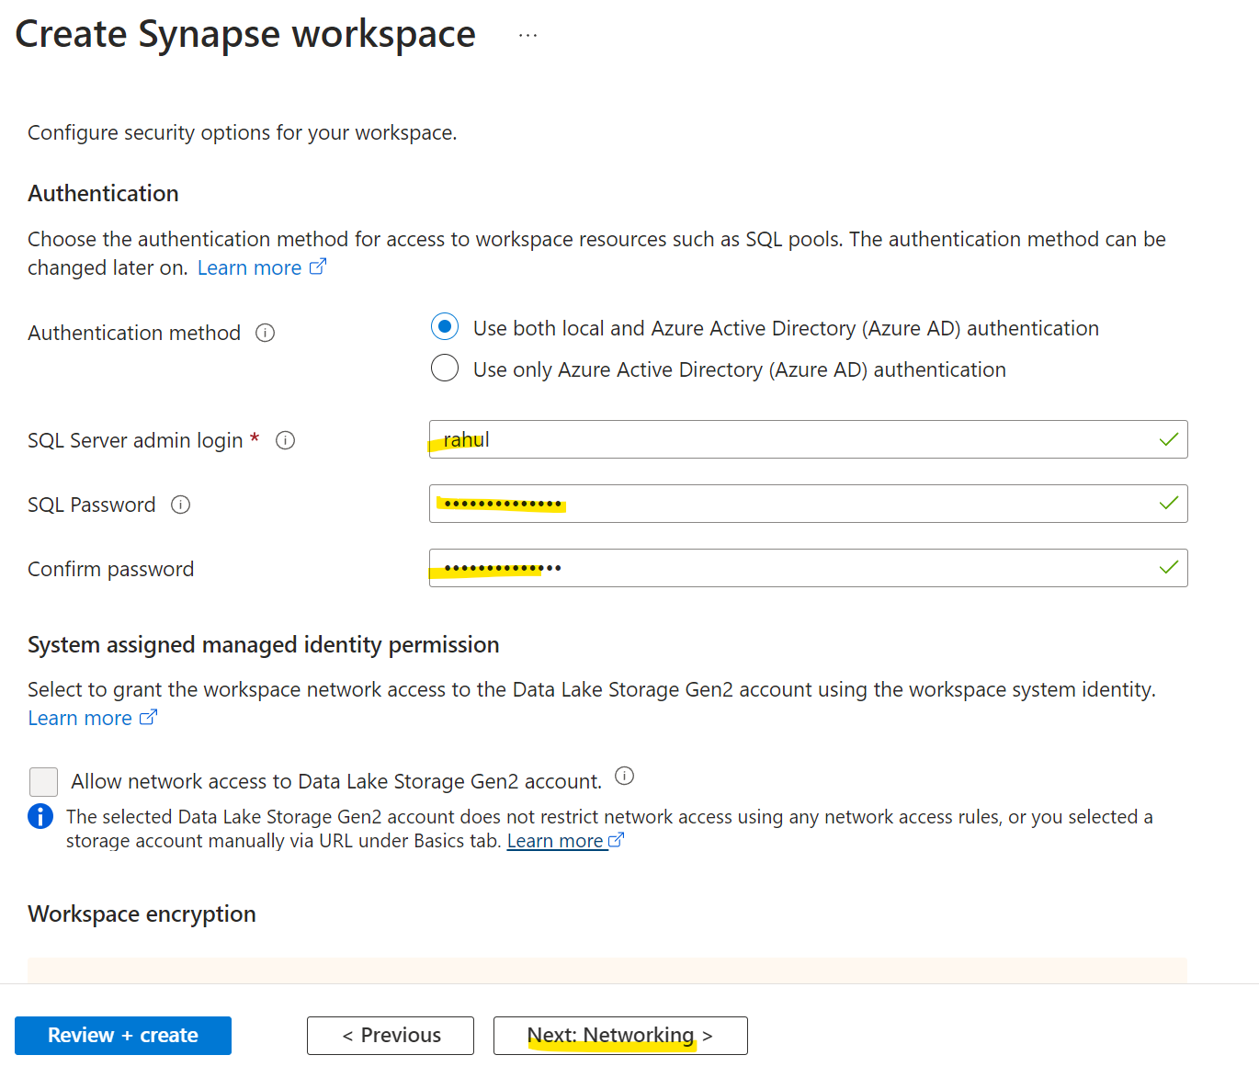

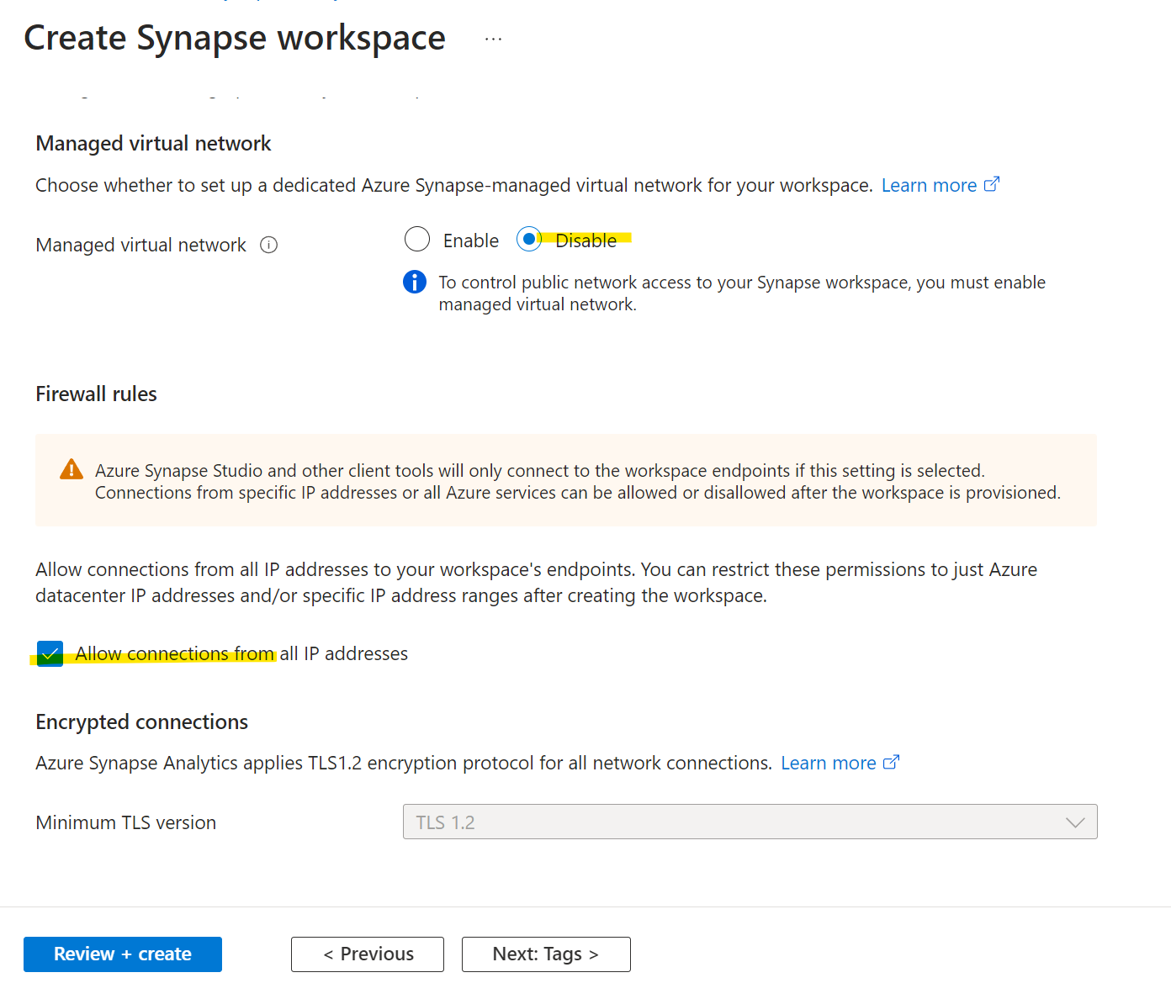

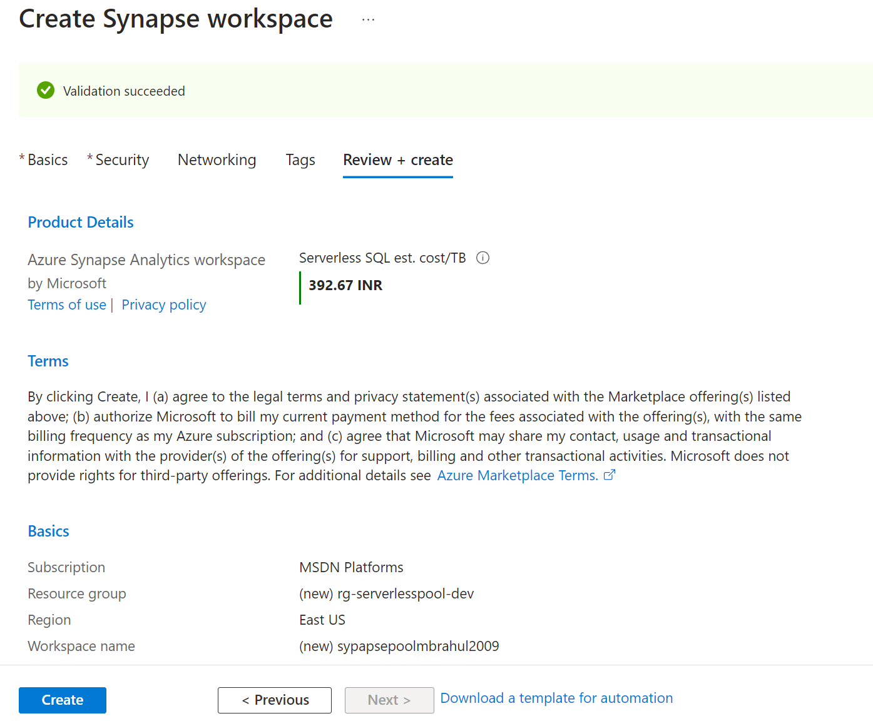

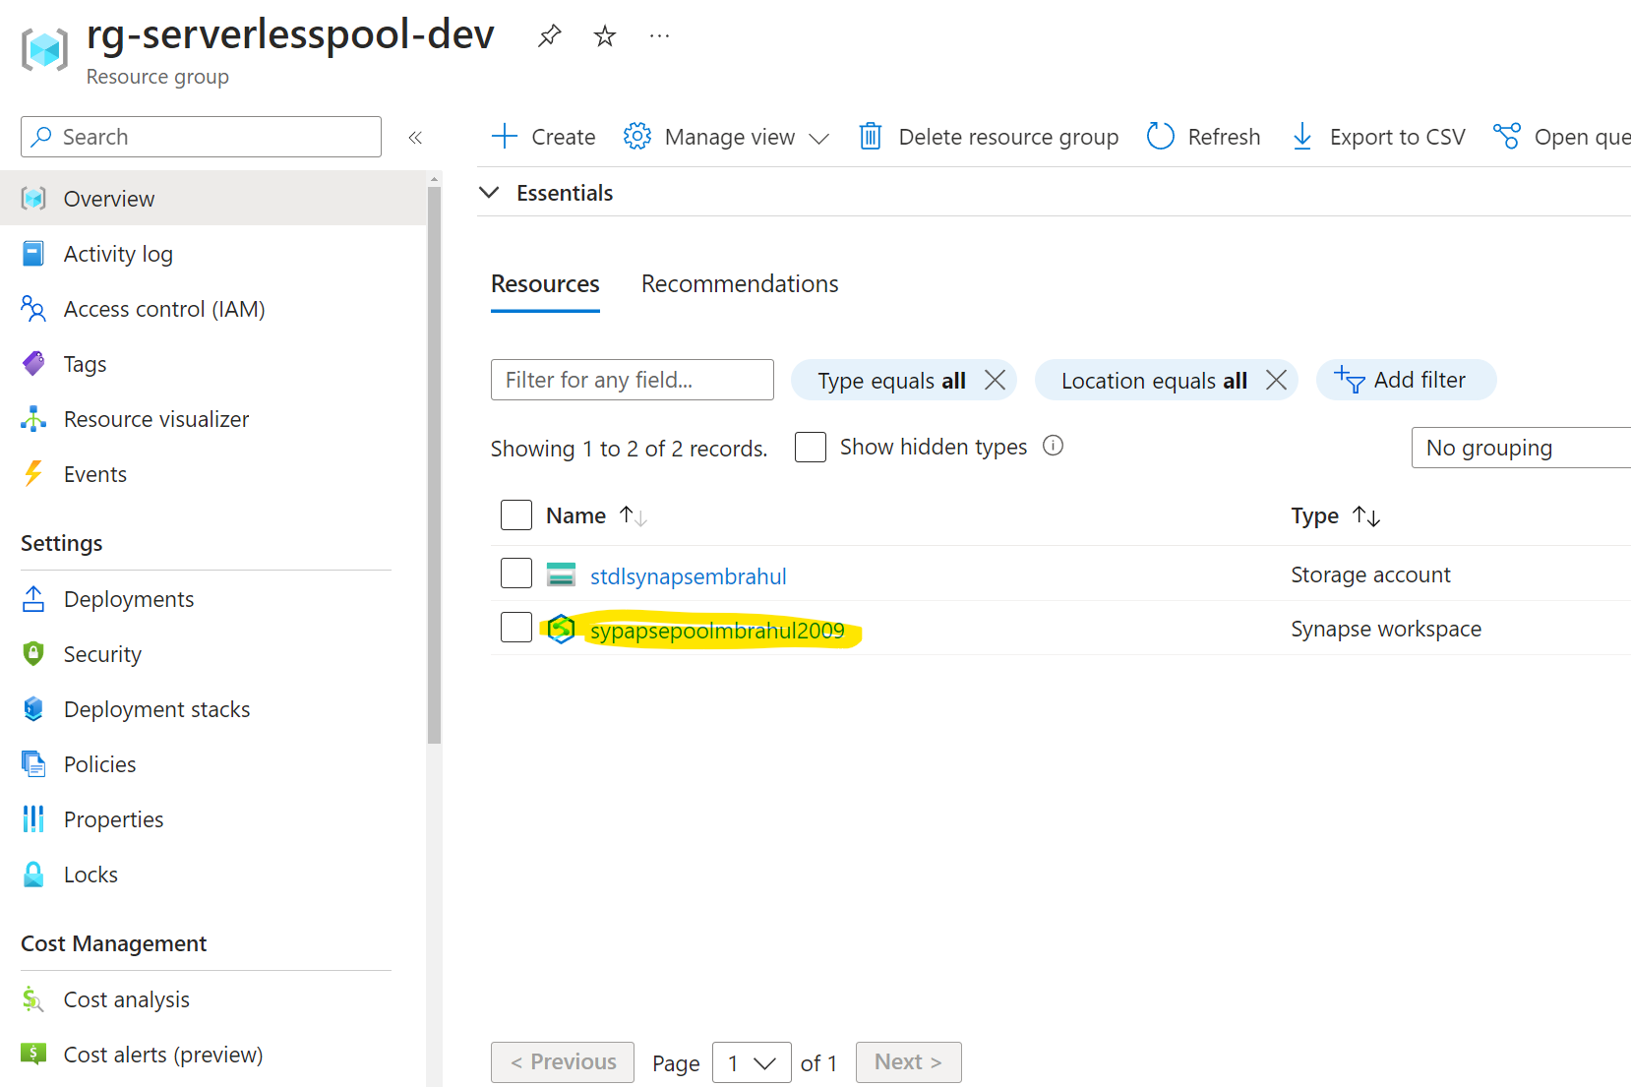

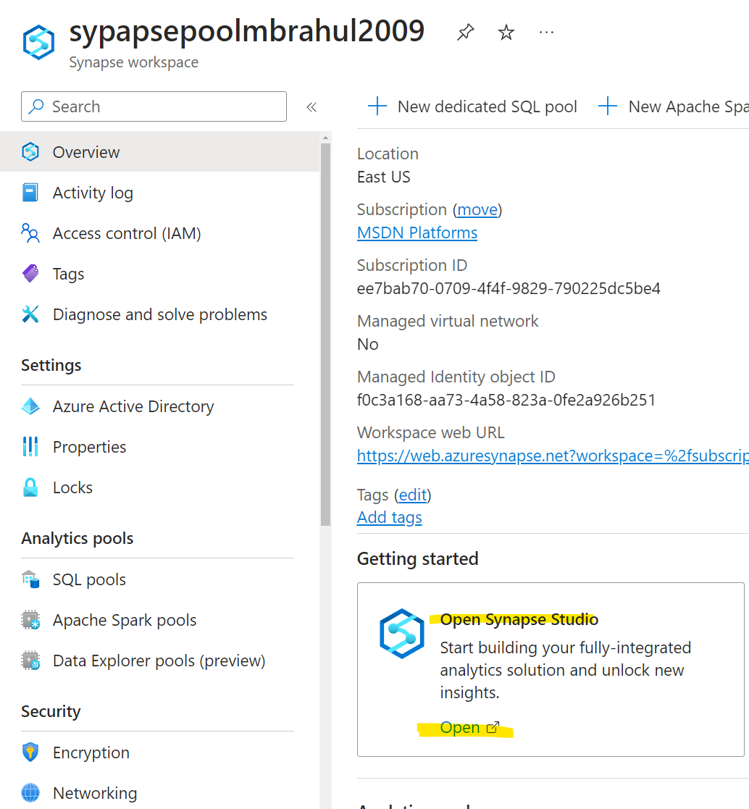

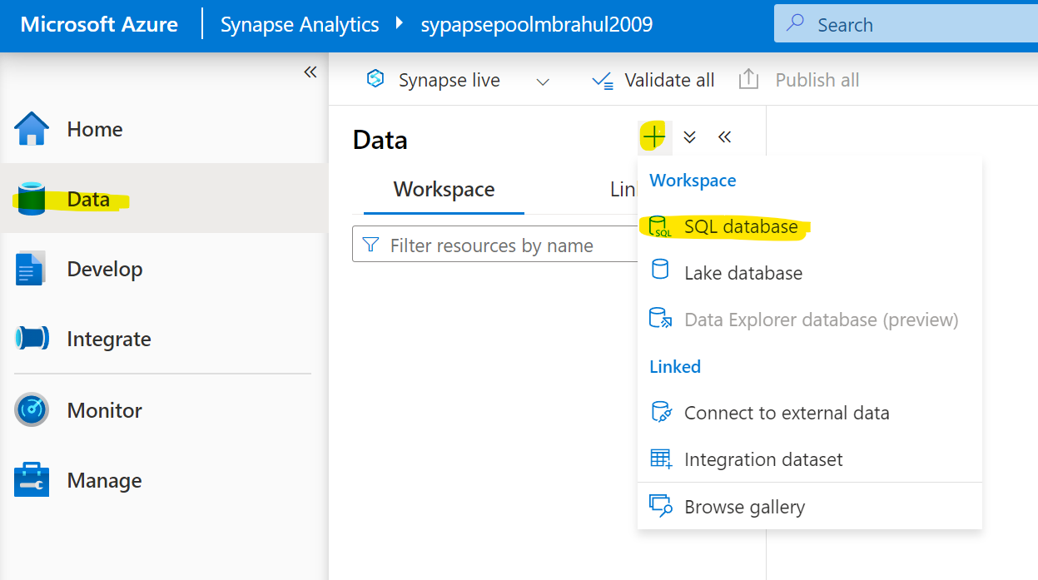

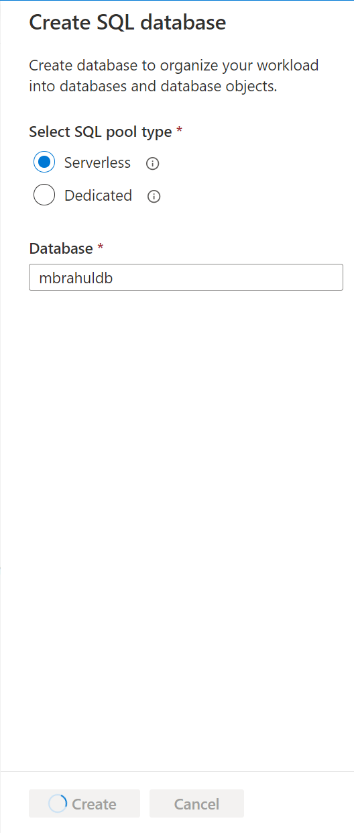

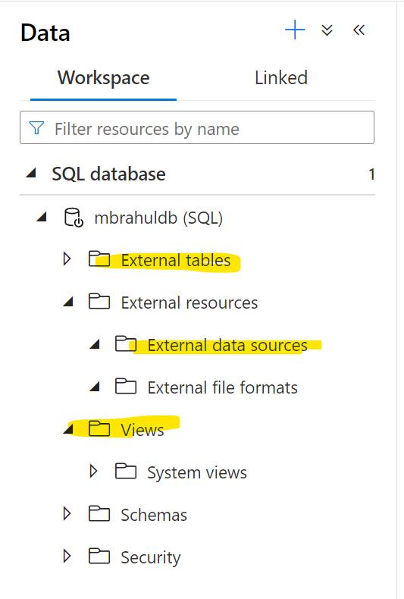

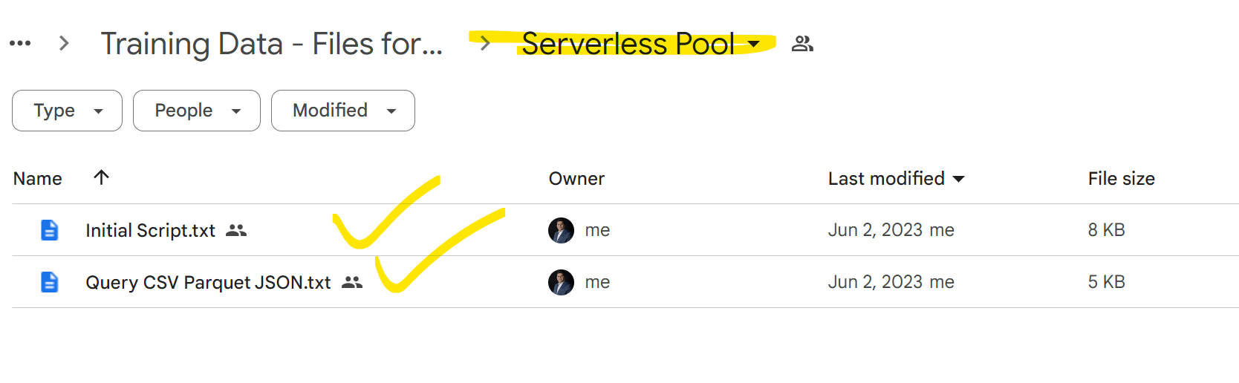

if db_name() = 'master'
throw 50001, 'This script cannot be executed in master database. Create new database and run the script there.', 1;

if SERVERPROPERTY('EngineEdition') <> 11
throw 50001, 'This script must be executed on Azure Synapse - SQL serverless endpoint.', 1;

------------------------------------------------------------------------------------------
-- Part 1 - Cleanup script
-- This part removes objects from sample database
------------------------------------------------------------------------------------------
DROP VIEW IF EXISTS parquet.YellowTaxi
GO
DROP VIEW IF EXISTS json.Books
GO
DROP VIEW IF EXISTS csv.YellowTaxi
GO
IF (EXISTS(SELECT * FROM sys.external_tables WHERE name = 'Population')) BEGIN
DROP EXTERNAL TABLE csv.Population
END
IF (EXISTS(SELECT * FROM sys.external_file_formats WHERE name = 'QuotedCsvWithHeader')) BEGIN
DROP EXTERNAL FILE FORMAT QuotedCsvWithHeader
END
GO
IF (EXISTS(SELECT * FROM sys.external_file_formats WHERE name = 'QuotedCsvWithoutHeader')) BEGIN
DROP EXTERNAL FILE FORMAT QuotedCsvWithoutHeader
END
GO
IF (EXISTS(SELECT * FROM sys.external_file_formats WHERE name = 'NativeParquet')) BEGIN
DROP EXTERNAL FILE FORMAT NativeParquet
END
GO
IF (EXISTS(SELECT * FROM sys.external_file_formats WHERE name = 'DeltaLakeFormat')) BEGIN
DROP EXTERNAL FILE FORMAT DeltaLakeFormat
END
GO
DROP SCHEMA IF EXISTS parquet;
GO
DROP SCHEMA IF EXISTS csv;
GO
DROP SCHEMA IF EXISTS json;
GO

IF (EXISTS(SELECT * FROM sys.external_data_sources WHERE name = 'SqlOnDemandDemo')) BEGIN
DROP EXTERNAL DATA SOURCE SqlOnDemandDemo
END

IF (EXISTS(SELECT * FROM sys.external_data_sources WHERE name = 'DeltaLakeStorage')) BEGIN
DROP EXTERNAL DATA SOURCE DeltaLakeStorage
END

IF (EXISTS(SELECT * FROM sys.external_data_sources WHERE name = 'AzureOpenData')) BEGIN
DROP EXTERNAL DATA SOURCE AzureOpenData
END

IF (EXISTS(SELECT * FROM sys.external_data_sources WHERE name = 'YellowTaxi')) BEGIN
DROP EXTERNAL DATA SOURCE YellowTaxi
END

IF (EXISTS(SELECT * FROM sys.external_data_sources WHERE name = 'GreenTaxi')) BEGIN
DROP EXTERNAL DATA SOURCE GreenTaxi
END

IF NOT EXISTS (SELECT * FROM sys.symmetric_keys) BEGIN
declare @pasword nvarchar(400) = CAST(newid() as VARCHAR(400));
EXEC('CREATE MASTER KEY ENCRYPTION BY PASSWORD = ''' + @pasword + '''')
END

IF EXISTS
(SELECT * FROM sys.credentials
WHERE name = 'https://sqlondemandstorage.blob.core.windows.net')
DROP CREDENTIAL [https://sqlondemandstorage.blob.core.windows.net]
GO

IF EXISTS
(SELECT * FROM sys.database_scoped_credentials
WHERE name = 'sqlondemand')
DROP DATABASE SCOPED CREDENTIAL [sqlondemand]
GO

IF EXISTS
(SELECT * FROM sys.database_scoped_credentials
WHERE name = 'WorkspaceIdentity')
DROP DATABASE SCOPED CREDENTIAL [WorkspaceIdentity]
GO

------------------------------------------------------------------------------------------
-- Part 2 - initialization script
-- This part creates required objects in sample database
------------------------------------------------------------------------------------------

-- create database-scoped credential for the containers in demo storage account
-- this credential will be used in OPENROWSET function with data source that uses relative file URL
CREATE DATABASE SCOPED CREDENTIAL [sqlondemand]
WITH IDENTITY='SHARED ACCESS SIGNATURE',
SECRET = 'sv=2018-03-28&ss=bf&srt=sco&sp=rl&st=2019-10-14T12%3A10%3A25Z&se=2061-12-31T12%3A10%3A00Z&sig=KlSU2ullCscyTS0An0nozEpo4tO5JAgGBvw%2FJX2lguw%3D'
GO
-- Create credential that will allow user to impersonate using Managed Identity assigned to workspace
CREATE DATABASE SCOPED CREDENTIAL WorkspaceIdentity WITH IDENTITY = 'Managed Identity'
GO

-- SQL logins only:
-- create server-scoped credential for the containers in demo storage account
-- SQL logins will use this credential in OPENROWSET function without data source that uses absolute file URL
CREATE CREDENTIAL [https://sqlondemandstorage.blob.core.windows.net]
WITH IDENTITY='SHARED ACCESS SIGNATURE',
SECRET = 'sv=2018-03-28&ss=bf&srt=sco&sp=rl&st=2019-10-14T12%3A10%3A25Z&se=2061-12-31T12%3A10%3A00Z&sig=KlSU2ullCscyTS0An0nozEpo4tO5JAgGBvw%2FJX2lguw%3D'
GO

CREATE SCHEMA parquet;
GO
CREATE SCHEMA csv;
GO
CREATE SCHEMA json;
GO

-- Create external data source secured using credential
CREATE EXTERNAL DATA SOURCE SqlOnDemandDemo WITH (
LOCATION = 'https://sqlondemandstorage.blob.core.windows.net',
CREDENTIAL = sqlondemand
);
GO

-- Data source referencing Delta Lake folders
CREATE EXTERNAL DATA SOURCE DeltaLakeStorage WITH (
LOCATION = 'https://sqlondemandstorage.blob.core.windows.net/delta-lake',
CREDENTIAL = sqlondemand
);
GO

-- Create publicly available external data sources
CREATE EXTERNAL DATA SOURCE AzureOpenData
WITH ( LOCATION = 'https://azureopendatastorage.blob.core.windows.net/')
GO
CREATE EXTERNAL DATA SOURCE YellowTaxi
WITH ( LOCATION = 'https://azureopendatastorage.blob.core.windows.net/nyctlc/yellow/')
GO
CREATE EXTERNAL DATA SOURCE GreenTaxi
WITH ( LOCATION = 'https://azureopendatastorage.blob.core.windows.net/nyctlc/green/')
GO

CREATE EXTERNAL FILE FORMAT QuotedCsvWithHeader
WITH (
FORMAT_TYPE = DELIMITEDTEXT,
FORMAT_OPTIONS (
FIELD_TERMINATOR = ',',
STRING_DELIMITER = '"',
FIRST_ROW = 2
)
);
GO
CREATE EXTERNAL FILE FORMAT QuotedCsvWithoutHeader
WITH (
FORMAT_TYPE = DELIMITEDTEXT,
FORMAT_OPTIONS (
FIELD_TERMINATOR = ',',
STRING_DELIMITER = '"',
FIRST_ROW = 1
)
);
GO
CREATE EXTERNAL FILE FORMAT NativeParquet
WITH (
FORMAT_TYPE = PARQUET
);
GO
CREATE EXTERNAL FILE FORMAT DeltaLakeFormat
WITH (
FORMAT_TYPE = DELTA
);
GO

CREATE EXTERNAL TABLE csv.population
(
[country_code] VARCHAR (5) COLLATE Latin1_General_BIN2,
[country_name] VARCHAR (100) COLLATE Latin1_General_BIN2,
[year] smallint,
[population] bigint
)
WITH (
LOCATION = 'csv/population/population.csv',
DATA_SOURCE = SqlOnDemandDemo,
FILE_FORMAT = QuotedCsvWithHeader
);
GO

CREATE VIEW parquet.YellowTaxi
AS SELECT *, nyc.filepath(1) AS [year], nyc.filepath(2) AS [month]
FROM
OPENROWSET(
BULK 'parquet/taxi/year=*/month=*/*.parquet',
DATA_SOURCE = 'SqlOnDemandDemo',
FORMAT='PARQUET'
) AS nyc
GO

CREATE VIEW csv.YellowTaxi
AS
SELECT *, nyc.filepath(1) AS [year], nyc.filepath(2) AS [month]
FROM OPENROWSET(
BULK 'csv/taxi/yellow_tripdata_*-*.csv',
DATA_SOURCE = 'SqlOnDemandDemo',
FORMAT = 'CSV',
FIRSTROW = 2
)
WITH (
vendor_id VARCHAR(100) COLLATE Latin1_General_BIN2,
pickup_datetime DATETIME2,
dropoff_datetime DATETIME2,
passenger_count INT,
trip_distance FLOAT,
rate_code INT,
store_and_fwd_flag VARCHAR(100) COLLATE Latin1_General_BIN2,
pickup_location_id INT,
dropoff_location_id INT,
payment_type INT,
fare_amount FLOAT,
extra FLOAT,
mta_tax FLOAT,
tip_amount FLOAT,
tolls_amount FLOAT,
improvement_surcharge FLOAT,
total_amount FLOAT
) AS nyc
GO

CREATE VIEW json.Books
AS SELECT *
FROM
OPENROWSET(
BULK 'json/books/*.json',
DATA_SOURCE = 'SqlOnDemandDemo',
FORMAT='CSV',
FIELDTERMINATOR ='0x0b',
FIELDQUOTE = '0x0b',
ROWTERMINATOR = '0x0b'
)
WITH (
content varchar(8000)
) AS books;

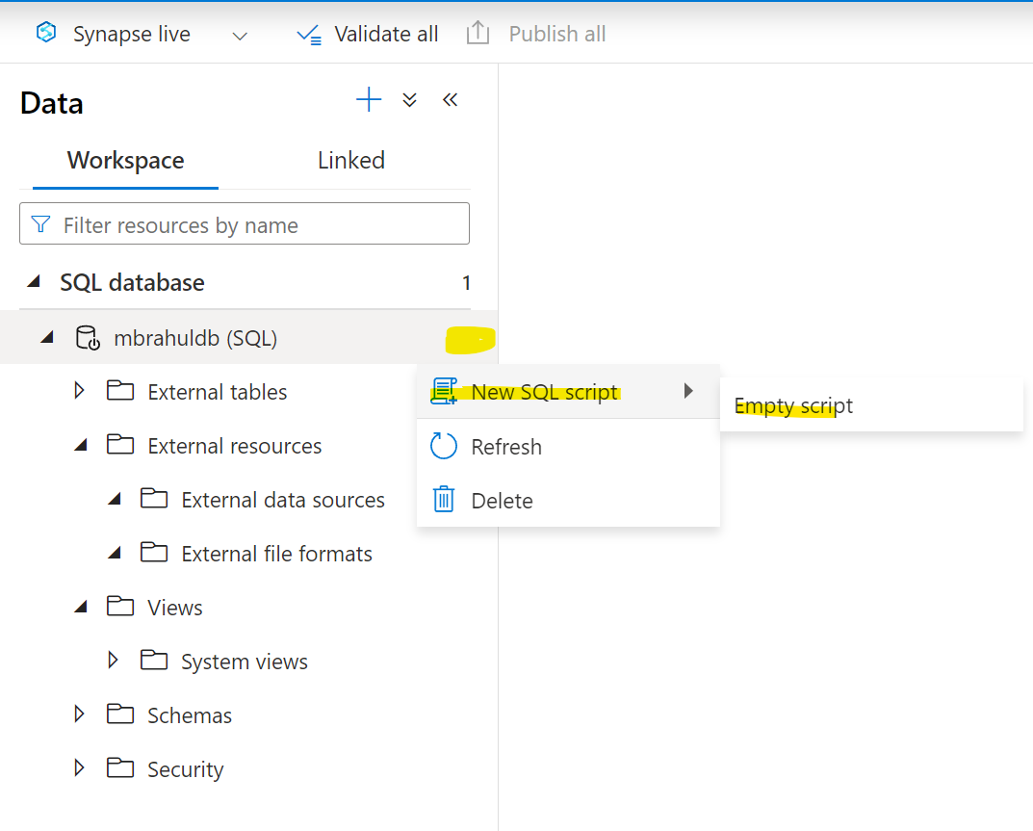

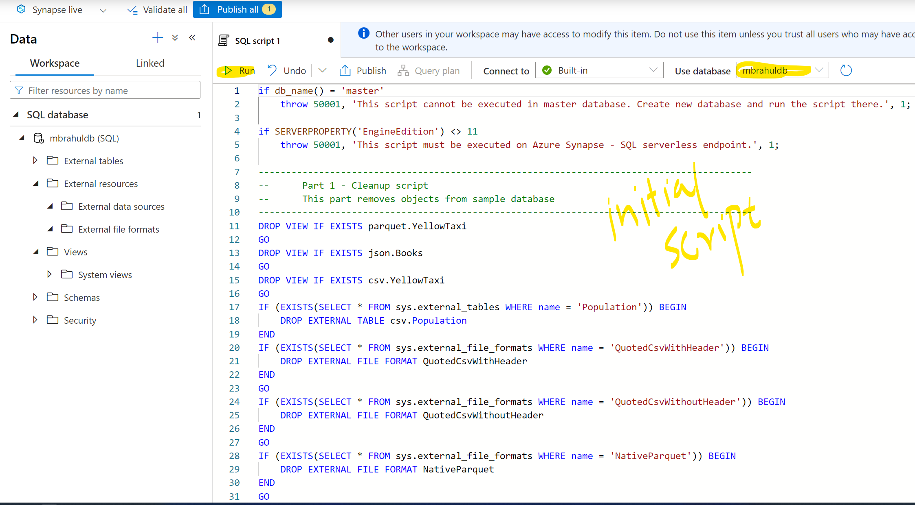

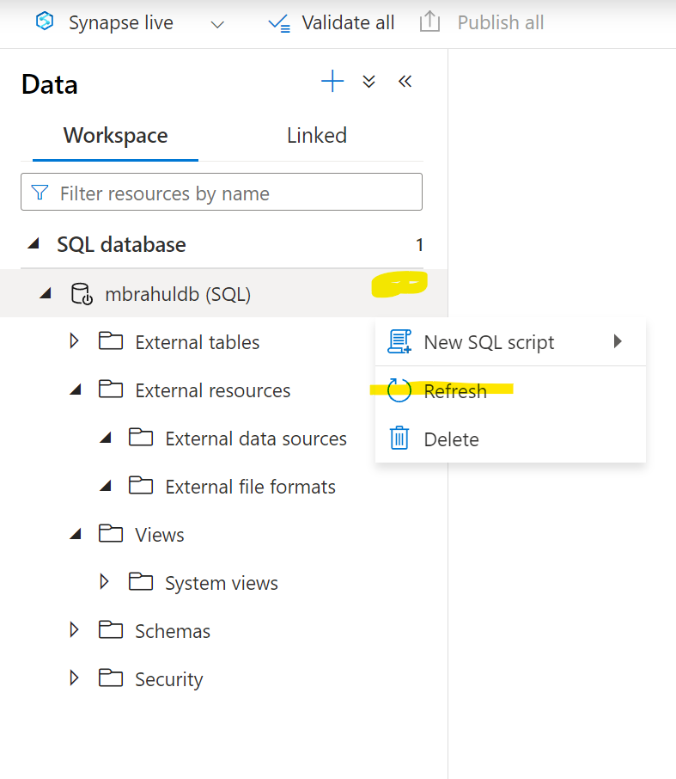

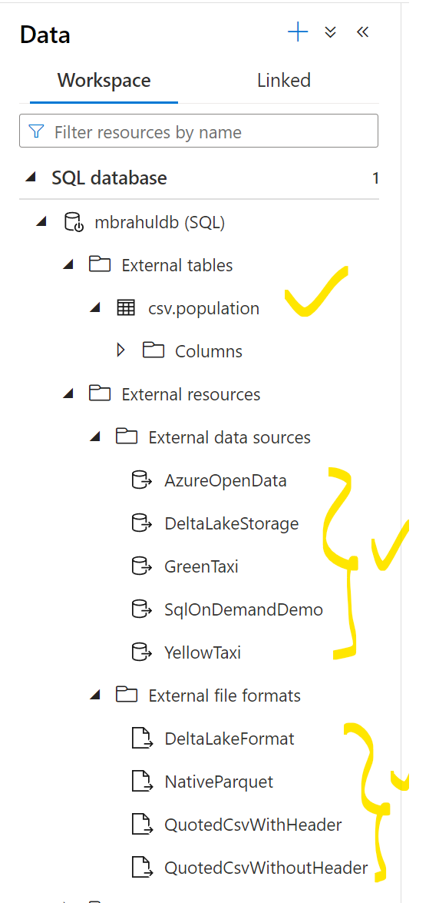

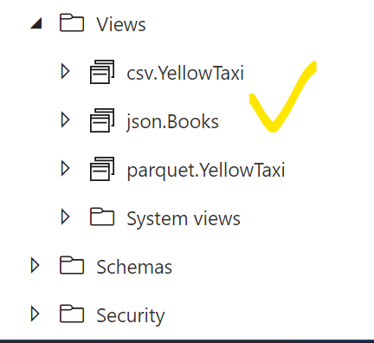

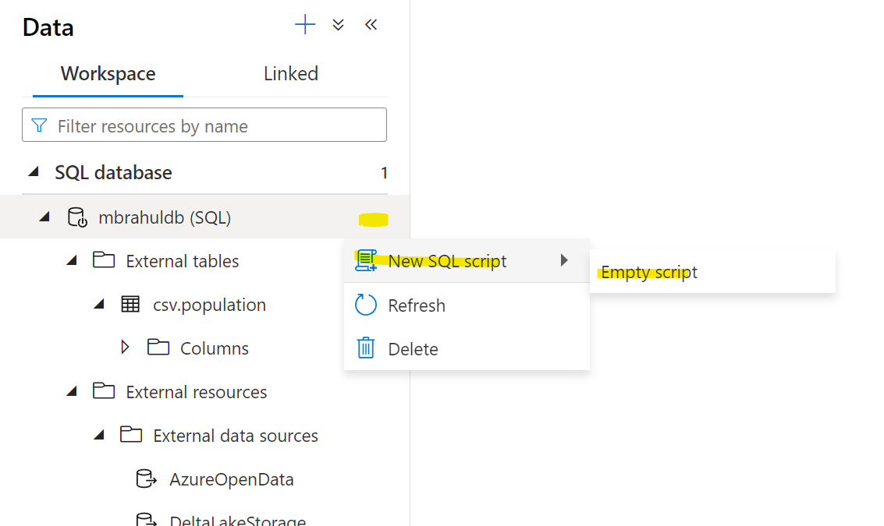

select top 10 *
from openrowset(
bulk 'https://pandemicdatalake.blob.core.windows.net/public/curated/covid-19/ecdc_cases/latest/ecdc_cases.csv',
format = 'csv',
parser_version = '2.0',
firstrow = 2 ) as rows

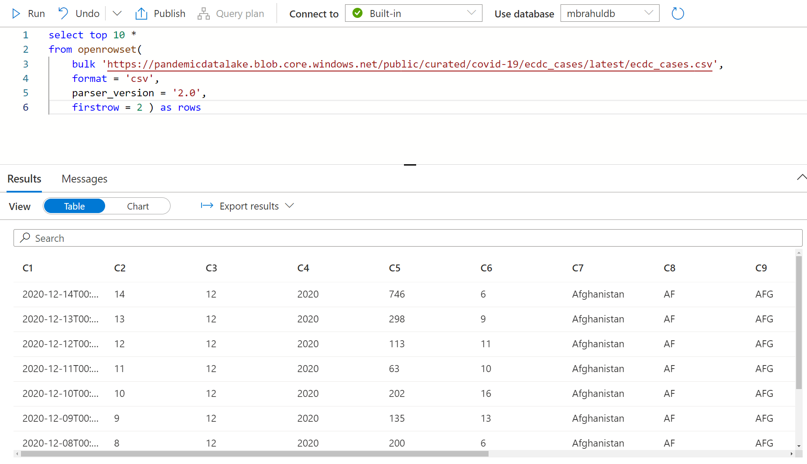

create external data source covid
with ( location = 'https://pandemicdatalake.blob.core.windows.net/public/curated/covid-19/ecdc_cases' );

select top 10 *
from openrowset(
bulk 'latest/ecdc_cases.csv',
data_source = 'covid',
format = 'csv',
parser_version ='2.0',
firstrow = 2
) as rows

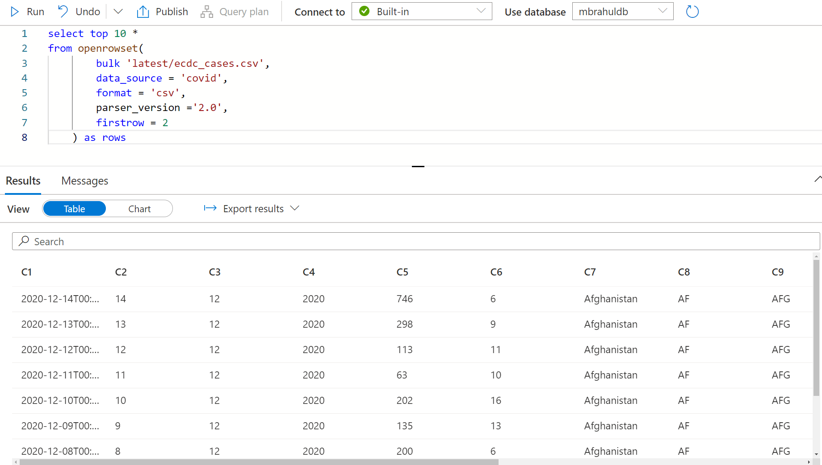

select top 10 *
from openrowset(
bulk 'latest/ecdc_cases.csv',
data_source = 'covid',
format = 'csv',
parser_version = '2.0',
firstrow = 2
) with (
date_rep date 1,
cases int 5,
geo_id varchar(6) 8
) as rows

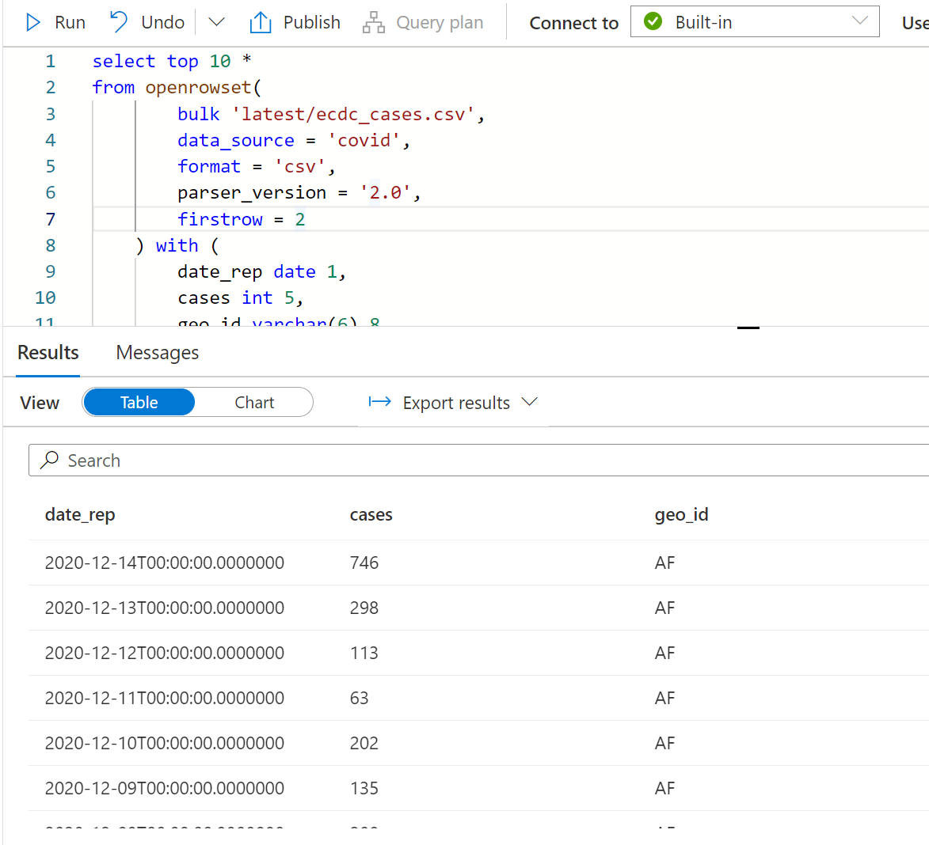

SELECT *
FROM OPENROWSET(
BULK 'csv/population/population.csv',
DATA_SOURCE = 'SqlOnDemandDemo',
FORMAT = 'CSV', PARSER_VERSION = '2.0',
FIELDTERMINATOR =',',
ROWTERMINATOR = '\n'
)
WITH (
[country_code] VARCHAR (5) COLLATE Latin1_General_BIN2,
[country_name] VARCHAR (100) COLLATE Latin1_General_BIN2,
[year] smallint,
[population] bigint
) AS [r]
WHERE
country_name = 'Luxembourg'
AND year = 2017;

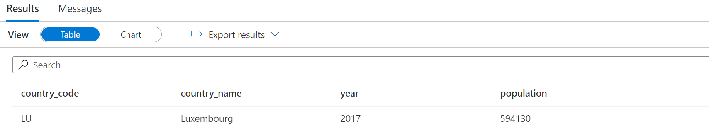

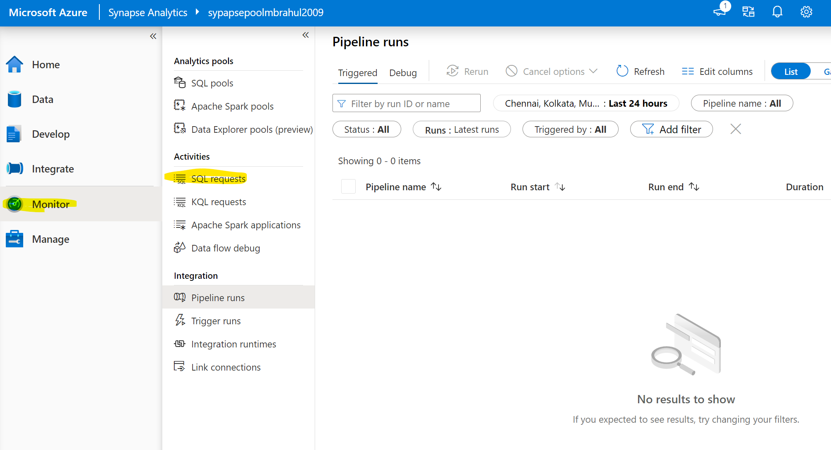

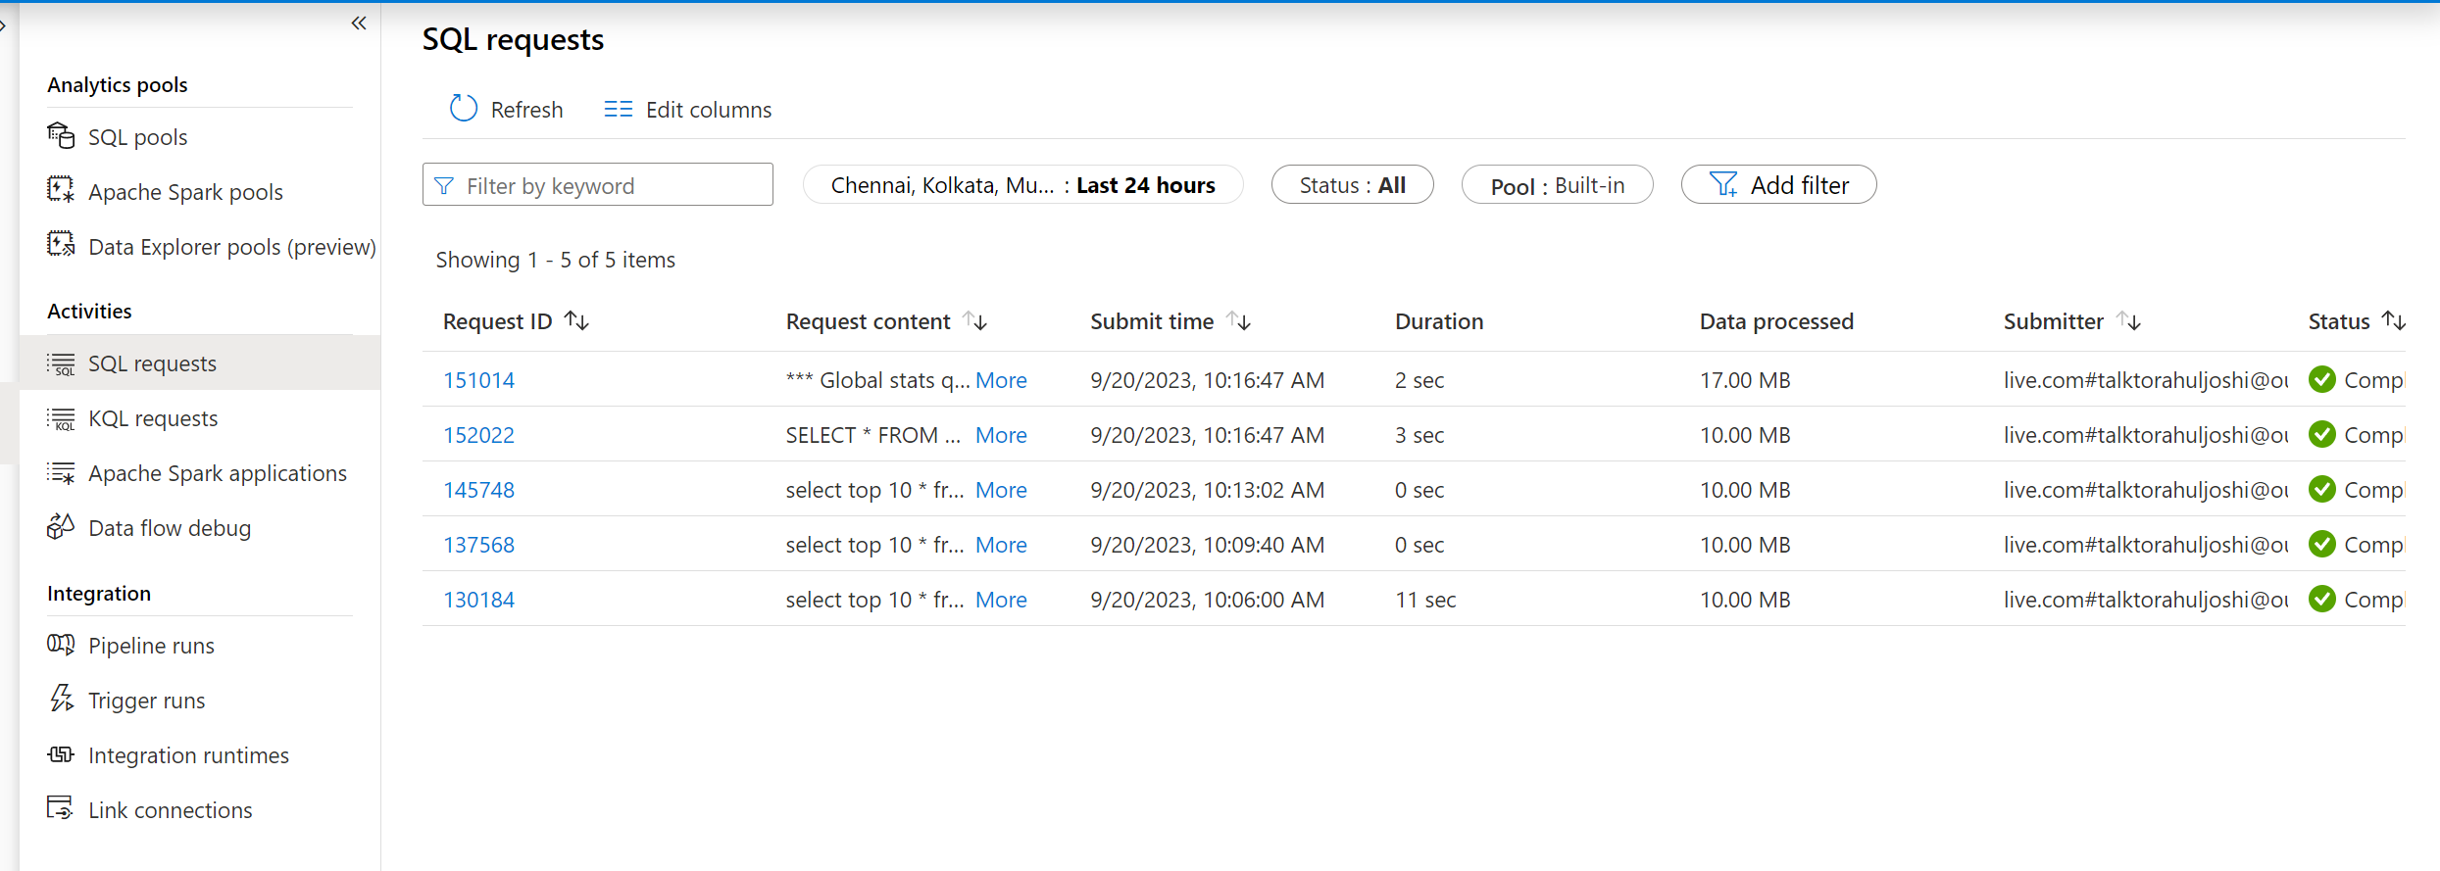

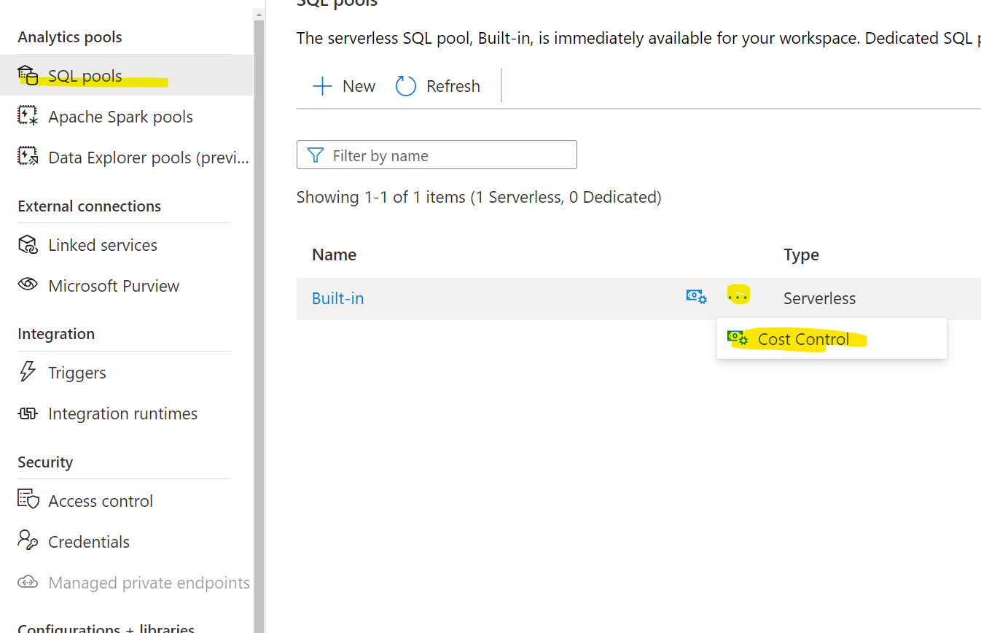

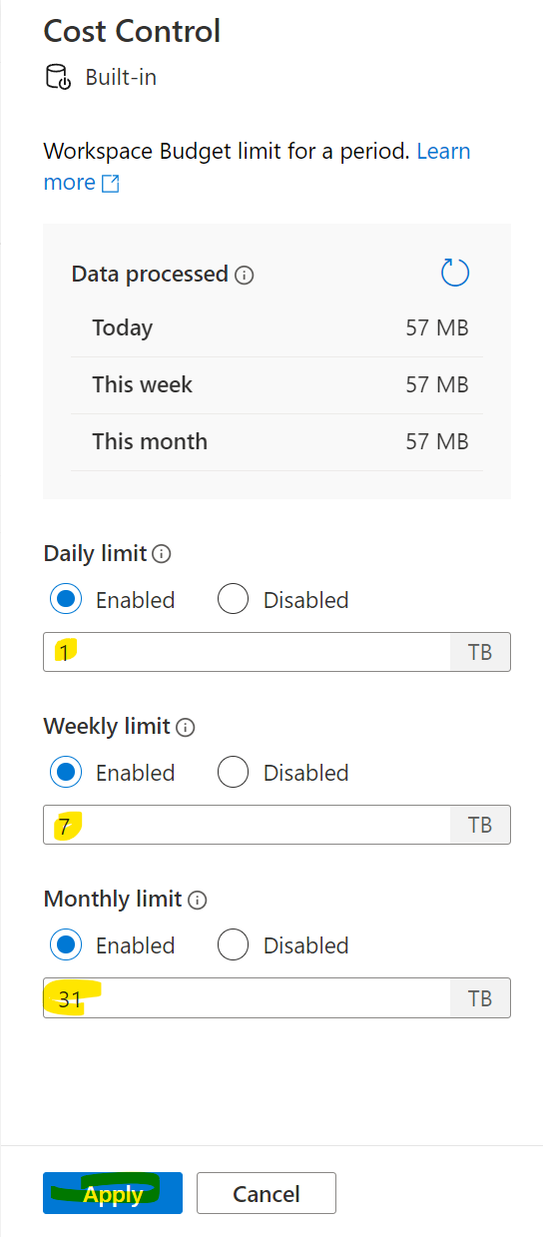

https://www.upsolver.com/blog/apache-parquet-why-use

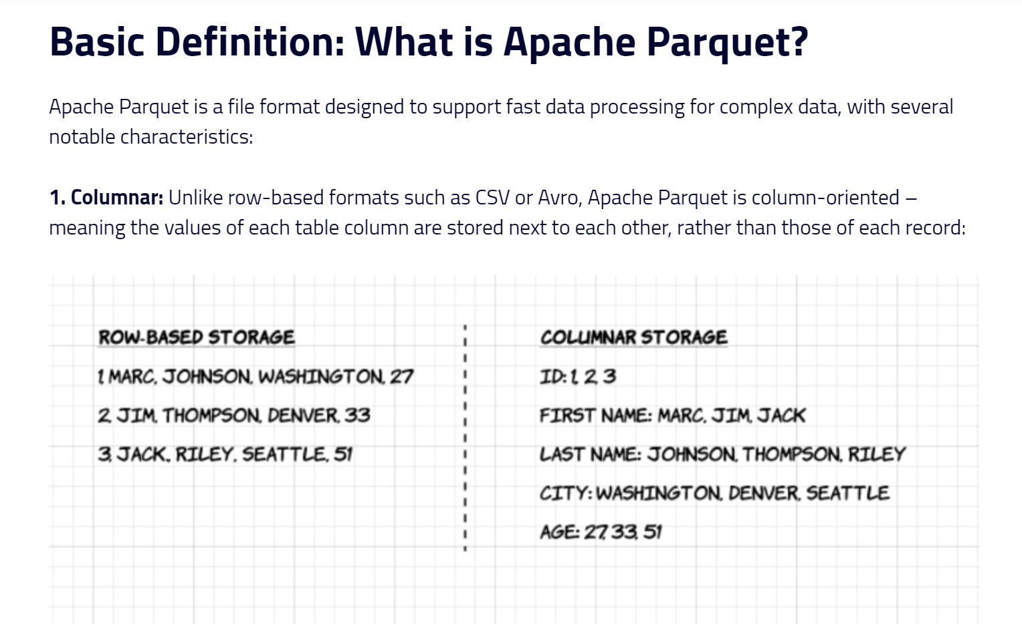
2. Open-source: Parquet is free to use and open source under the Apache Hadoop license, and is compatible with most Hadoop data processing frameworks. To quote the project website, “Apache Parquet is… available to any project… regardless of the choice of data processing framework, data model, or programming language.”

3. Self-describing: In addition to data, a Parquet file contains metadata including schema and structure. Each file stores both the data and the standards used for accessing each record – making it easier to decouple services that write, store, and read Parquet files.

Advantages of Parquet Columnar Storage – Why Should You Use It?
The above characteristics of the Apache Parquet file format create several distinct benefits when it comes to storing and analyzing large volumes of data. Let’s look at some of them in more depth.

Compression
File compression is the act of taking a file and making it smaller. In Parquet, compression is performed column by column and it is built to support flexible compression options and extendable encoding schemas per data type – e.g., different encoding can be used for compressing integer and string data.
Parquet data can be compressed using these encoding methods:
  - Dictionary encoding: this is enabled automatically and dynamically for data with a small number of unique values.
  - Bit packing: Storage of integers is usually done with dedicated 32 or 64 bits per integer. This allows more efficient storage of small integers.
  - Run length encoding (RLE): when the same value occurs multiple times, a single value is stored once along with the number of occurrences. Parquet implements a combined version of bit packing and RLE, in which the encoding switches based on which produces the best compression results.

Performance
As opposed to row-based file formats like CSV, Parquet is optimized for performance. When running queries on your Parquet-based file-system, you can focus only on the relevant data very quickly. Moreover, the amount of data scanned will be way smaller and will result in less I/O usage. To understand this, let’s look a bit deeper into how Parquet files are structured.
As we mentioned above, Parquet is a self-described format, so each file contains both data and metadata. Parquet files are composed of row groups, header and footer. Each row group contains data from the same columns. The same columns are stored together in each row group:

SELECT
YEAR(tpepPickupDateTime),
passengerCount,
COUNT(*) AS cnt
FROM
OPENROWSET(
BULK 'puYear=2018/puMonth=*/*.snappy.parquet',
DATA_SOURCE = 'YellowTaxi',
FORMAT='PARQUET'
) WITH (
tpepPickupDateTime DATETIME2,
passengerCount INT
) AS nyc
GROUP BY
passengerCount,
YEAR(tpepPickupDateTime)
ORDER BY
YEAR(tpepPickupDateTime),
passengerCount;

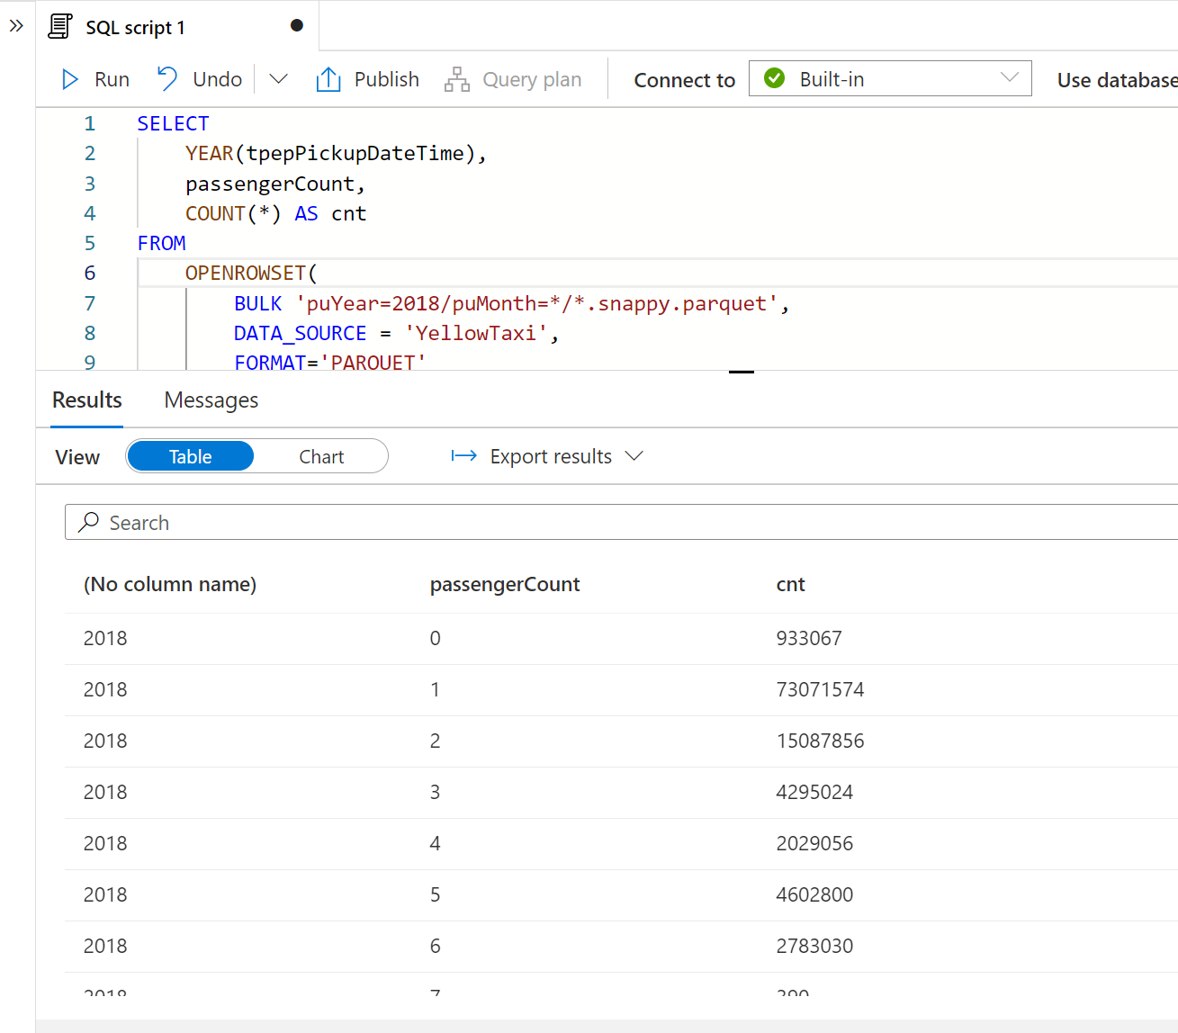

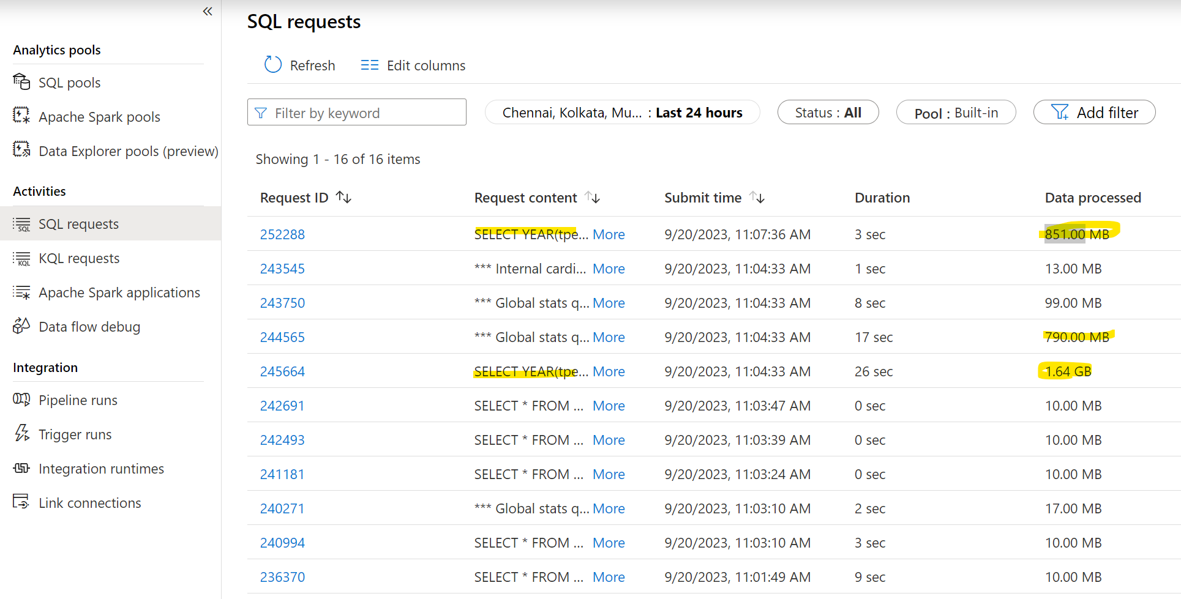

SELECT
YEAR(pickup_datetime) AS [year],
SUM(passenger_count) AS passengers_total,
COUNT(*) AS [rides_total]
FROM
OPENROWSET(
BULK 'csv/taxi/*.csv',
DATA_SOURCE = 'SqlOnDemandDemo',
FORMAT = 'CSV',
PARSER_VERSION = '2.0',
FIRSTROW = 2
) WITH (
pickup_datetime DATETIME2 2,
passenger_count INT 4
) AS nyc
GROUP BY
YEAR(pickup_datetime)
ORDER BY
YEAR(pickup_datetime);

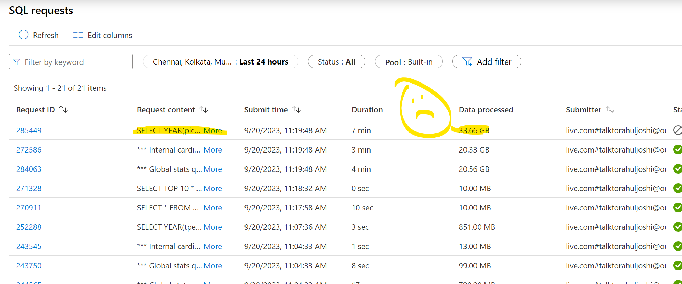

End of Day 8

